1. Extract the zip file to a folder;
2. Open the SAS program "ahrf2016-17.sas" in SAS software;
3. Change the infile path in the SAS code, and let it point to where the data file “ahrf2017.asc” saved.

For example, in the original SAS code, the infile path is “C:\” as below.

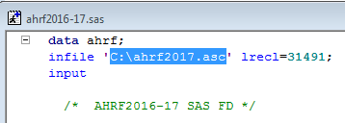

If you saved the data file “ahrf2017.asc” in the folder “C:\AHRF\County\Data”, then change it to that folder:

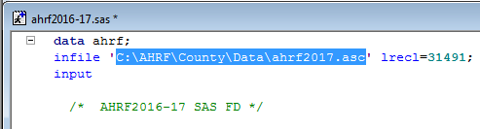

1. Run the SAS code and get SAS dataset.